Software Requirements Specification
for
Software Defined Network
Version 1.0 approved
Prepared by
Kaljate Arati
Kallure Pratiksha
Mane Kajal
Kumbhar Ashwini

BRACT’s Vishwakarma Institute of Information Technology

Table of Contents
Table of Contents ii
Revision History ii
1. Introduction 1
1.1 Purpose 1
1.2 Document Conventions 1
1.3 Intended Audience and Reading Suggestions 1
1.4 Product Scope 1
1.5 References 2
2. Overall Description 3
2.1 Product Perspective 3
2.2 Product Functions 3
2.3 User Classes and Characteristics 3
2.4 Operating Environment 3
2.5 Design and Implementation Constraints 4
2.6 User Documentation 4
2.7 Assumptions and Dependencies 4
3. External Interface Requirements 4
3.1 User Interfaces 4
3.2 Hardware Interfaces 4
3.3 Software Interfaces 5
3.4 Communications Interfaces 5
4. System Features 5
4.1 OpenFlow Controller 5
4.2 Firewall System...................................................................................................................6
5. Other Nonfunctional Requirements 7
5.1 Performance Requirements 7
5.2 Safety Requirements 7
5.3 Security Requirements 8
5.4 Software Quality Attributes 8
5.5 Business Rules 8
6. Other Requirements 8

Revision History
Name | Date | Reason For Changes | Version

Introduction

Purpose
Increasing access to the networks results additional data traffic across wide area network. These demands require huge parallel processing on thousands of interconnected servers. Additional network capacity servers with large & increase in bandwidth are needed in the data center to provide security in the network.enabling frequent changes in to network conditions and state,providing support for network configuration in high level language.Try to providing better visibility and control over tasks for performing network diagnosis and troubleshooting. SDN provides security functions in a dynamic and free composable manner, based on immediate detection results concatenating adaptive programmable security functions. Purpose of the proposed mechanism is to detect malicious behaviors and reports to network administrators as intrusion events.

Document Conventions
- Font Size for heading : 18(B)
- Font Size for Sub heading : 14(B)
- Normal Text : 12
- Line spacing : 1

Intended Audience and Reading Suggestions
From the network security and availability perspective, there exists an increasing amount of firewall attacks during the last years, so security is a challenging task. SDN is an emerging technology which separates the data and control functions of networking devices, such as routers, packet switches, and LAN switches, with a well-defined Application Programming Interface (API) between the two.

Product Scope
In future, networking will rely on software to pick up the pace the innovation in network. SDN can transform today’s static networks into more flexible programmable platform to provide a scalability to support large data centers. It will also provide virtualization that is needed to support automated, dynamic and secure cloud environment.firewall application by writing code for a SDN controller POX in python. The SDN fire-wall monitors all the internal traffic in the network and allows se-lective blocking of host-to-host communication based on network state and time of the day.Here we proposed the implement Firewall Genetic algorithm to monitor the network traffic . which helps to provide the security towards SDN.

References
1] Hyojoon Kim and Nick Feamster, “Improving Network Management with Software Defined Networking”,Georgia Institute of Technology IEEE Communications Magazine • February 2013.

[2]Nick McKeown ,Guru Parulkar ,Tom Anderson,Larry Peterson ,”OpenFlow :Enabling Innovation in Campus Networks”,ACM SIGCOMM Computer Communication Review April 2008.

[3]BROCADE “Software Defined Networking in Campus Network”,White Paper.

[4]Depandra Dhakal,Bishal Pradhan,Sunil Dhimal,”Campus Network using Software Defined Networking”, International Journal of Computer Application ,march 2016.

[5]Wolfgang Braun * and Michael Menth,”Software-Defined Networking Using OpenFlow: Protocols,Applications and Architectural Design Choices”,Future Internet 2014, 6, 302-336; doi:10.3390/fi6020302.

[6]Van-Giang Nguyen* and Young-Han Kim*,”SDN-Based Enterprise and Campus Networks:A Case of VLAN Management”,J Inf Process Syst, Vol.12, No.3, pp.511~524, September 2016 | 515.

[7]Andreas Voellmy,Hyojoon Kim,”Procera: A Language for High-Level Reactive Network Control”,HotSDN’12, August 13, 2012, Helsinki, Finland. Copyright 2012 ACM 978-1-4503-1477-0/12/08.

[8]Hyojoon Kim,Theophilus Benson,”The Evolution of Network Configuration:A Tale of Two Campuses”,University of Wisconsin IMC’11, November 2–4, 2011, Berlin, Germany. Copyright 2011 ACM 978-1-4503-1013-0/11/11.

[9]Sakir Sezer ,Sandra Scott-Hayward ,Barber Fraser,David Lake”Are We Ready For SDN? Implementation Challenges for Software Define Networks”, IEEE Communication Magzine July 2013.

[10]Syed Taha Ali,Adam Radford ,Sanjay Jha,”A Survay of Securing Networks Using Software Defined Networking”,IEEE Transaction on Realibility 2015.

Overall Description

Product Perspective
Security at network level states an important research area since consumers and companies push their data continuously into cloud environments and more data is transferred over large distances. From the network security and availability perspective, there exist an increasing amount of Security issues. Software Defined Networking (SDN) promises a large variety of possibilities to improve network monitoring and traffic steering. OpenFlow is a well-established protocol in SDN. Incoming traffic reaches an OpenFlow enabled switch, Intrusion firewall is used to maintain a history of recurring events including IP addresses as well as information from external sources. It monitors the traffic over SDN and redirects the suspicious traffic to cloud security providers.

Product Functions
- Emulate the SDN and maintain it
- To design algorithm for firewall in SDN
- To maintain the network

User Classes and Characteristics
- System Administrator:
- Responsible for managing the system.
- It is also responsible for error detections occurred in system and correct them as well.
- Perform enhancements in algorithm.
- Responsible to overlook all SDN controller operations.

- User:
- He is frequent user of the network, who has no intent to harm the network in any way.
- Uses network for its own purpose.

- Malicious User:
- This term actually refers to the attacker, it is the user which is trying to degrade the quality of the network.
- Sometimes there intention is to shut down the whole network.
- They perform the attack on SDN.

Operating Environment
Software resources:
- Operating System: Ubuntu
- IDE: Mininet.
- Programming Language: Java

Hardware resources:
- MININET EMULATOR
- 4GB RAM
- INTEL CORE I3 PROCESSOR
- 500 GB HARD DISK

Design and Implementation Constraints

Configuration of network: The SDN should be properly designed and must be in working condition.

User Documentation
We provide project report having project design and functionality details.

Assumptions and Dependencies
It is assumed that SDN can transform today’s static networks into more flexible programmable platform to provide a scalability to support large data centers. It would provide virtualization that is needed to support automated, dynamic and secure cloud environment. The hardware designed will work correctly with the third party operating system and the developed software. Because the device acquires database updates through Server.

External Interface Requirements

User Interfaces
SDN interfaces:
- Flexible programmable SDN switches
- A centralized SDN controller

Hardware Interfaces
1. Pentium Core i3 processor
2. 500 GB hard drive
3. 4 GB RAM

Software Interfaces
The software interface is the UI of the emulator. Also interface of command line for the controller will be used in order to design the network. A graphical interface will describe the architecture of the SDN system. The attack and result of prevention of attack will be shown on the command line.
1. Ubuntu OS
2. Mininet emulator
3. VirtualBox

Communications Interfaces
OpenFlow Protocol:
OpenFlow is a well-established protocol in SDN deployments. Incoming traffic reaches an OpenFlow enabled switch (OF-switch). This switch is equipped with a base rule set in the forwarding tables. This base rule set acts as a light IDS that maintains a history of recurring events including involved IP addresses as well as information from external sources. These sources include public available black-lists, white-lists, geo-location data and their severities.

System Features
Software-Defined Networking transforms network architecture into traditional network backbones of rich service-delivery platforms.

Software-Defined Networking focuses on three key features:
- Separation of the control plane from the data plane
- A centralized controller and view of the network
- Programmability of the network by external applications

4.1 OpenFlow Controller

- Description:
An OpenFlow controller is an application that manages flow control in a software-defined networking (SDN) environment.SDN controllers functions according to OpenFlow protocol. The SDN controller acts as a sort of operating system (OS) for the network. All communications between applications and devices have to go through the controller. The OpenFlow protocol connects controller software to network devices so that server software can tell switches where to send packets. The controller uses the OpenFlow protocol to configure network devices and choose the best path for application traffic.
- Stimulus/Response Sequences:
If one switch is malicious, it will send inaccurate messages to the controller. For instance, a malicious switch may inform the controller that its processing power and its bandwidth are very huge, which may mislead the controller to assign more flows to the switch. The malicious switch may lead to a large amount of packet loss, which will have a terrible effect on the SDN’s performance.
- Functional Requirements:
SDN is a more centralized approach, in which the controller communicates with switches via OpenFlow protocol. The controller is just like a God role in SDN, and each switch works under the instructions from it. Switches only have storing and forwarding functions. However, the controller knows all the information of the networks, including topological structure, the bandwidth between neighboring switches and so on.

4.2 Firewall System
- Description:
It is a firewall implemented in a software defined net-work, using mininet and python based on the custom topology .

In figure 2, a small network is set up on the virtual machine, with mininet installed. This network contains a remote controller, six switches; each with a host. This topology is utilized to test different principles and strategies characterized in the firewall design.

Algorithm: firewall.py: The code actualizes a firewall application in a SDN to block particular host-to-host correspondence based on the time of the day. It recognises the ip addresses to be blocked.
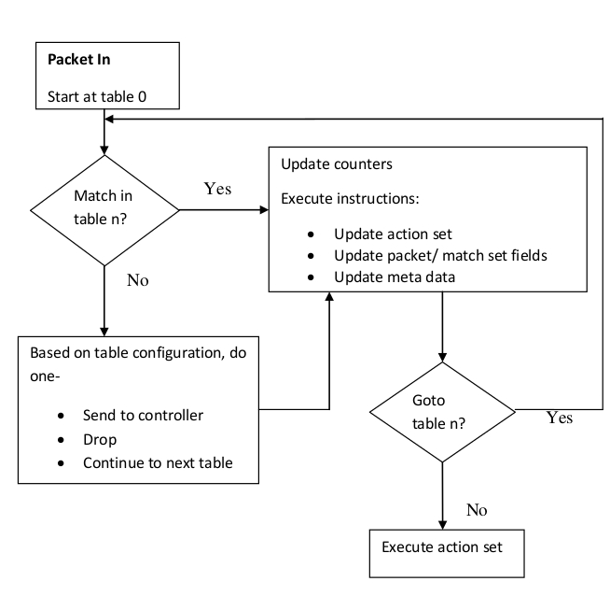

Fig. 1. open flow switch algorithm

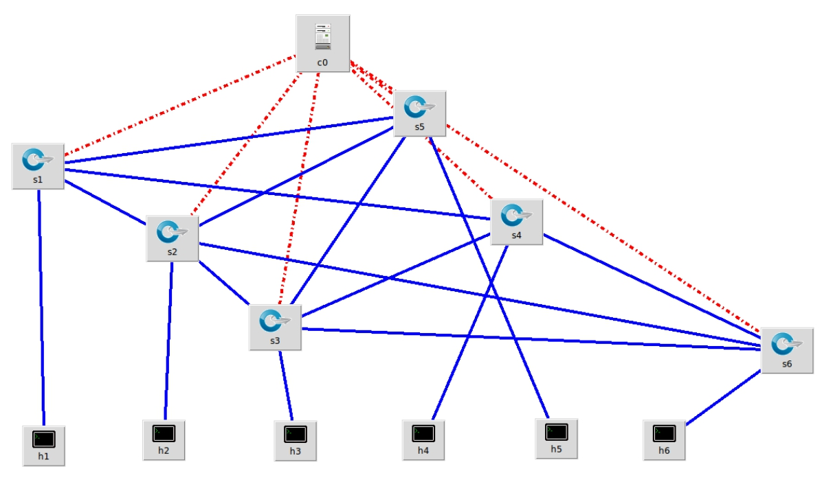

Fig. 2. Custom topology for firewall

from certain other ip addresses and also directs the controller to add specific flow-entries in the flow tables of the switches, so that packets from these blocked ip addresses are independently handled by the switches in future.

- Detection techniques of the Firewall:
Anomaly: Identifies events unexpected. However, new rules are difficult to create.
Signature: Compare events with strings known. However, new attacks are not detected.
Stateful: Compare profiles previously created for each protocol with observed events, identifying some types of unusual activities. However, these profiles vary depending of the vendor

Other Nonfunctional Requirements

Performance Requirements
The performance requirement includes performance of the controller and performance of the proposed system. Also the network should work properly. Our approach follows the overall goal to reduce false positives and improve the quality of the forwarding rule set progressively. In coincidence, our solution claims to immediately redirect attack traffic that would cause an overload of the on-site network to a cloud security provider that is able to cope with this amount of traffic, having in mind privacy concerns of the consumer. Following this, our solution redirects only attack traffic to a cloud security provider leaving the trustworthy part untouched.

Safety Requirements
In Software Defined Networking (SDN) architecture, the control plane is separated from the data plane. On one hand, OpenFlow switches can only store and forward packets, which leaves all decisions to be made by the controller. On the other hand, the controller has a global view over the SDN. But if any switch is captured by an adversary, it may mislead the controller to make inaccurate decisions which may have terrible influences on the overall networks.Hence, we are detecting malicious OpenFlow switches and suspicious traffic by using firewall.

Security Requirements
Username and password (login)
User Verification

Software Quality Attributes
We are using vendor-independent protocols like OpenFlow, which are not depending on special vendor working groups, fosters the adoption and modularity of our solution and helps companies to get away from strong vendor dependencies. Besides this, NETCONF is designed to change the configuration itself of a device, in contrast OpenFlow is creating forwarding table entries which is much more flexible and adaptive.

Business Rules
Incoming traffic reaches an OpenFlow enabled switch (OF-switch). This switch is equipped with a base rule set in the forwarding tables. This base rule set acts as a light firewall that maintains a history of recurring events including involved IP addresses as well as information from external sources.

Other Requirements
1.Security Aspects
2.LAN Connectivity
3.Network Configuration
4.User inputs

